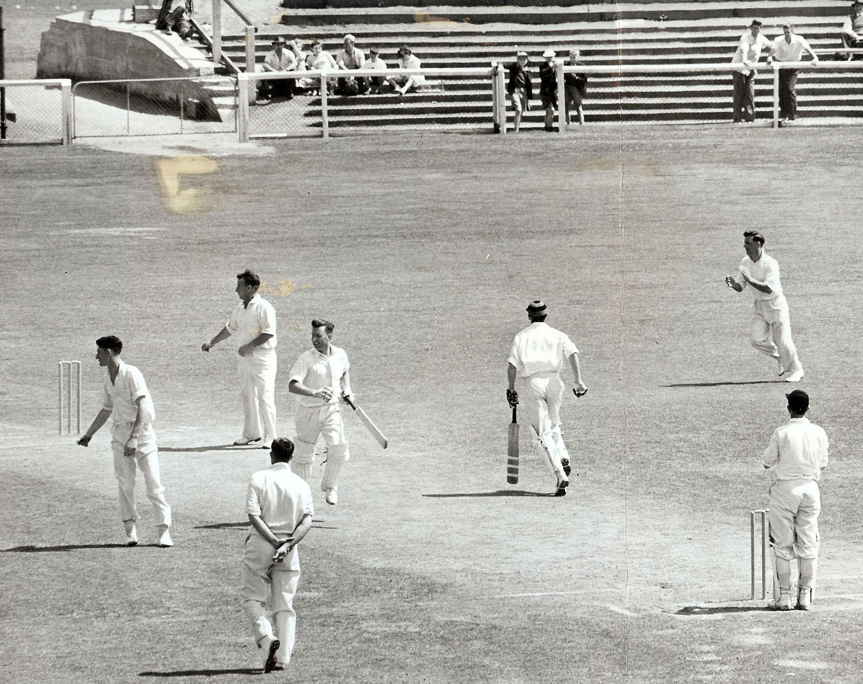

**GT Dowling hits the winning run off AM Moir. ME Chapple non striker. MR Edmunds wicket keeper.**

**Canterbury v Otago 28 December 1959 Lancaster Park**

**Otago 96 and 278. Canterbury 284 and 91/4 Canterbury won by 6 wickets**